Hemostasis and coagulation of blood
Coagulation theory
1-Release of a small amount of platelets factor III.
2-Platelet factor III react with factors VIII, IX and X in presence of calcium ion forming a small amount of plasma thromboplastin.
3-There is conversion of prothrombin to thrombin.
4-Thrombin serves as catalyst in the initiator reaction (phase 1) resulting in the release of more platelet factor III.
5-Thrombin as catalyst in (phase 2) resulting in formation more plasma thromboplastine.
6-The additional plasma thromboplastin speed up conversion of prothrombin to thrombin with thrombin itself catalyzing the conversion of prothrombin.
7-When a critical concentration of thrombin is reached, fibrinogen converted to fibrin.
Laboratory tests for coagulation defects:
1. Bleeding time:
Bleeding time is a simple and sometimes useful technique for evaluating the efficiency of capillary-platelets aspect of hemostasis. A standard-sized incision is made around 10 mm long and 1 mm deep. The time from when the incision is made until all bleeding has stopped is measured and is called the bleeding time. Every 30 seconds, filter paper or a paper towel is used to draw off the blood.
Interpretation of bleeding time:
Normal bleeding time from 2-5 minutes may be prolonged in the following condition:
1-Defects in blood vessel wall.
2-Platelets defects either thrombocytopenia or presence of abnormal platelets.
3-Sever liver disease.
4-Administration of large doses of anticoagulants.
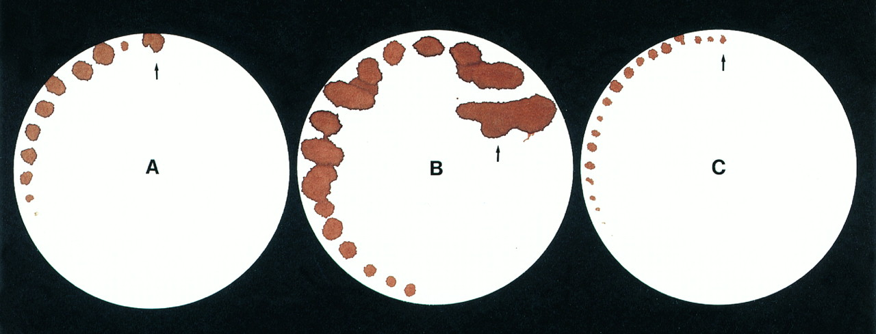
2.Platelets evaluation and counting:
Counting:-
The total number of thrombocyte in peripheral blood can be determinted by a direct counting method or indirectly by an estimation made by examination of a stained blood film. The direct counting method is done in the same manner as is erythrocyte counting except that a different diluting fluid is used (Rees-Ecker, EDTA or ammonium oxalate.
The procedure:-
1-using an erythrocyte diluting pipette, rinse it with diluting fluid.
2-draw blood to the 0.5 mark.
3-draw diluting fluid to the 101mark.
4-shake the pipette for several minutes.
5-discard several drops.
6-fill both sides of the counting chamber.
7-place the hemocytometer in a moist chamber such as petri dish containing a piece of wet filter paper and allow to stand for 10-20 minutes.
8-count platelets in the entire central ruled area in each side of the counting chamber (25 squares of RBC in two side of hemocytometer chamber). Platelets identified as oval or rod shaped bodies approximately ½ the diameters of erythrocytes.
9-multiply the number of thrombocyte in the ruled area by 1000 to give total erythrocyte per cu mm.
Interpretation of platelets counts:
The normal thrombocyte count in domestic animals ranges from 175000-500000 cells/cu.mm. Any disease condition affecting bone marrow may result in thrombocytopenia. Thrombocytopenia is seen secondary in association with some bacterial and viral diseases, frequently accompanies autoimmune diseases such as autoimmune hemolytic anemia and systemic lupus erythrematosus. Thrombocytosis may occur transient as a response occurring in disease or following trauma.
3.Colt retraction:
If blood permitted to clot in a clean dry test tube, it will separate from the wall. Obvious abnormalities in clot retraction can be observed by placing a tube of blood (with no anticoagulant added) in incubator at 37 C⁰. A normal clot will retract markedly within two to four hours and by the end of 24 hours will be a compact mass. Clot retraction in animals varies between 25 and 60 percent of the serum in whole blood.
Interpretation of clot retraction:
Retraction of a formed clot is influenced by the number and function of platelets. Fibrinogen content of plasma as well as other chemical and enzymatic factors. Clot retraction is impaired in afibrinogenemia, thrombocytopenia and in some coagulation defect.
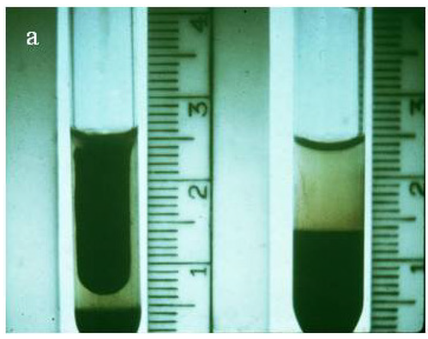
4. Clotting time:
Is the time required for a sample of blood with out anticoagulant to coagulate in vitro under standard conditions in capillary tube or test tube. This test is of no value in slight deficiencies of various factors as only a small amount of thrombin is required to form a fibrin clot. It is difficult to reveal defects in later stages of clotting as those occurring with deficiencies in factor V, factor X or in prothrombin deficiencies. Since only small number thrombocytes .
The clotting time per minutes bovine 3-15 ovine 2.5-11.5 equine 3.5-11.5 canine 4 feline 5-5.4
Interpretation of clotting time:
1-Defects in intrinsic system (hemophilia).
2-Thrombocytpenia.
3-Sever liver disease.
4-Some types of advanced neoplasia.
5-thrombocte disease.
6-ureamia.
